Safeguarding the Hollin Busk Area for Future Generations.
A Response Statement from a Local Residents Group to a Proposed Housing Development at Hollin Busk.
Planning Application 17/04673/OUT.

Friends of Hollin Busk
January 2018

Contents
1. Highlight Points
2. Background Scenario
3. History and Legacy
4. Embedded in Sheffield Planning Policy
5. New Housing Activity in the Upper Don Valley 2017
6. Transport and Traffic Management
7. The Green Environment and Supporting Wildlife
8. Water Management and Drainage
9. Heritage
10. Conclusions

1. Highlight Points
- Previous attempts at building houses on Hollin Busk have all been turned down by Sheffield City Council. An appeal to the Secretary of State in1998 was also turned down.
- The Hollin Busk area is a typical hill farming landscape of a green, rural, open character with significant views across the valley. This contrasts with the more urban development and industrial landscape in the valley bottom.
- The greenfields and Open Space are highly valued by the local community who regard the maintaining of this green, open, environment as an important legacy for future generations. The Community does not want housing development to encroach on to this area. The Greenbelt starts on the other side of Hollin Busk Lane.
- The Community wants to avoid a blanket of urban sprawl that creeps up the valley sides and fills in the green gaps between Stocksbridge, Deepcar and Bolsterstone.
- Sheffield City Council have specifically identified this area in The Core Strategy 2009 as being designated as Open Space that is not to be built upon as it maintains green open land between Stocksbridge and Deepcar, maintaining their individual identities.
- The Government White Paper February 2017 has a key theme of “the right homes in the right places” and quotes “the protection of open countryside”. The recent housing proposal for Hollin Busk is not in line with this strategy.
- The green, open space at Hollin Busk is much valued by ramblers, dog walkers, horse riders, cyclists and is a regular route for school children going to and from school. The flat nature of Hollin Busk Lane makes it a popular route.
- Residents on Carr Road enjoy exceptional views, including sunsets, across the fields at Hollin Busk. These would be obscured by a new development.
- Planning permission has recently been give to build 851 new houses on three brownfield sites in the Upper Don Valley. The expansion on to greenfields adjacent to the greenbelt is an unnecessary encroachment on open space valued by all.
- There is a high level of local feeling that this land should be retained as Open Space. A very large number of objections have been registered on the Sheffield City Council Planning website.
- Hollin Busk is an inappropriate location for new housing as there is not easy access to the main road network, as compared to the other new housing developments on brownfield sites in the valley bottom. This development is not in the original housing plan and is an opportunistic proposal.
- The proposed development is about 1 mile away from local shops and up a very steep hill. Due to the steepness of the locality, and an inadequate bus service, local people use cars to access the shops and to go to work.
- The junction of Carr Road with Manchester Road currently exceeds traffic capacity during peak weekday periods with significant tailbacks up Carr Road and both ways on Manchester Road. The addition of 413 new houses at Station Road will add to this congestion. An additional 93 houses at Hollin Busk would add further volume of cars. The problem is road capacity not sequencing of traffic lights.
- The proposed access to the new development for construction lorries, and new residents, is virtually opposite Royd Nursery and Infants School.
- The new development will effectively close-off green access to the Local Wildlife Site of Fox Glen. There is currently a project to encourage willow tits at this site being managed by Steel Valley Project.
- There is a green finger of land that runs up the valley sides separating Deepcar from Stocksbridge, the proposed development effectively severs this green finger.
- A wide range of birds and small mammals inhabit this area and they will be pushed further towards the adjacent Peak District Natural Park.
- Hollin Busk is an area where there has previously been a coal mine and a ganister mine. There are undoubtedly underground workings that have not been investigated that may influence underground drainage and possibly give rise to sinkholes.
- Surface water drainage through Fox Glen can be a problem in periods of heavy rain. A proposal to direct surface water from the new housing into Clough Dike, which runs through Fox Glen may cause a significant additional problem.
- Surface water runs down Carr Road at times of heavy rain and results in drain covers regularly overflowing and instances of sewage overflow. The plan to direct sewage from 93 more homes into the main pipe down Carr Road will considerably worsen this situation.
- The grade 2 listed building of Royd Farm, which dates back to the 16th century, will be totally engulfed on three sides seriously affecting its significance and setting.

2. Background Scenario
Stocksbridge and Deepcar are 12 miles to the north west of Sheffield and hence are on the fringes of the main city development. Some would say the area regards itself as slightly independent, although still part of the large City of Sheffield. It benefits from easy access to the countryside and, outside of the immediate valley, has an open, green aspect. The area to the NW of Sheffield is rather a “hidden gem” that is often overshadowed by the well known Peak District and the area to the SW of Sheffield.
It is an area of historical industrial development (quern stones, coal, refractories, steel) mainly in the valleys, surrounded by hill farming on the hill tops and valley sides.
Stocksbridge has a world-leading steel company that is a significant supplier of special steels to aerospace and other high technology engineering industries. However, a significant amount of the old industrial brownfield land in the bottom of the valley has now become available, and requires development. Fortunately, this is well-located close to main routes, including the Stocksbridge Bypass.
It is recognised that there is a continuing need for suitable housing for local residents and the brownfield sites in the valley are an appropriate opportunity for such developments.
The immediate location is rural. On the outskirts of the area is the Peak District National Park and the “reservoirs corridor” that runs from Langsett to Redmires.
Local people like the open, green aspect of the area as a place to live and also for outdoor recreational activities where they appreciate the open spaces for walking, trail running, mountain biking and horse riding etc. The area is much valued.
Stocksbridge, Deepcar and Bolsterstone are separate settlements that have respected, long standing, boundaries. The recognition of separate identities, and the prevention of an all-encompassing “urban sprawl” is valued by local residents. A housing development at Hollin Busk would threaten these historic boundaries.
Being of a rather independent spirit, local people have a lot of feeling for the area, particularly when there have been previous attempts to build on this open green space. This feeling has helped develop Sheffield City Council’s planning policy for the area, particularly at Hollin Busk.
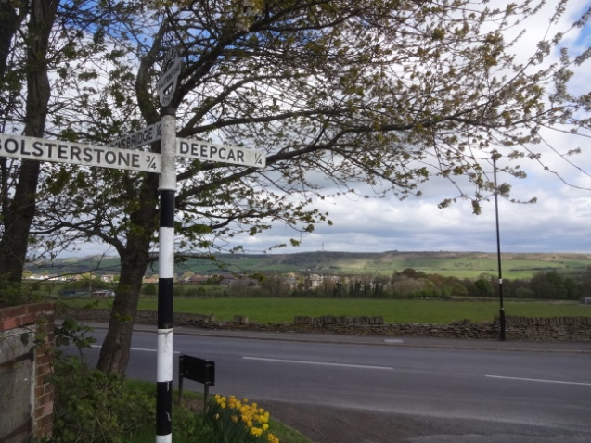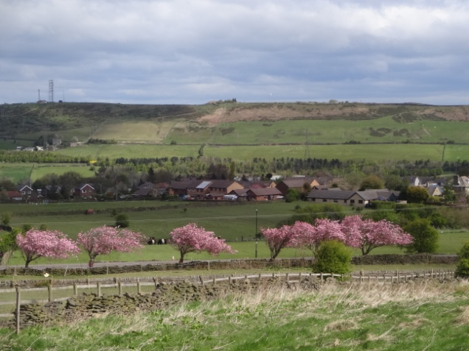
3. History and Legacy
There have been at least two previous attempts to build houses on this land. An application for development of Hollin Busk in 1989 was refused by Sheffield City Council and the applicants appealed to the Secretary of State. The decision to refuse the application was upheld. There was considerable local feeling in the community and it was the Council’s intention to designate these fields as greenbelt. The greenbelt starts on the other side of Hollin Busk Lane. However, this was omitted in error, and it was then not possible to enact this intention without opening discussion on other greenbelt issues in the Sheffield area. Sheffield City Council decided to give it the designation of Open Space, and Hollin Busk was specifically identified in policy documents as open green space that was not to be built upon.
This was then embedded in Sheffield planning strategy through a number of policy statements in the Sheffield Core Strategy 2009 which are outlined below.

4. Embedded in Sheffield Planning Policy
Sheffield Core Strategy 2009 - CS72 Protecting Countryside not in the Green Belt, states:- “12.8 The land at Hollin Busk is a large and integral part of the countryside south of Stocksbridge prominent in local views and providing an important visual break between the settlements of Stocksbridge and Deepcar. Its rural character is greatly valued locally and there is no need to develop it, as new housing can be provided on previously developed land in the urban area. Indeed protection of the area makes a significant contribution to the character and distinctiveness of Stocksbridge”.
Sheffield Core Strategy 2009. “3.16 The green, open and rural character of greenfield land south of Stocksbridge at Hollin Busk will be safeguarded through protecting it as Open Space”.
Sheffield Core Strategy 2009. Policy CS33 limits new housing to previously developed land within the urban area. The designated Open Space at Hollin Busk is environmentally important as it:-
- Checks the unrestricted sprawl of the built up areas of Stocksbridge and Deepcar.
- Prevents the merger of Stocksbridge and Deepcar.
- Assists the safeguarding of the countryside from encroachment.
The Sheffield Core Strategy 2009 is due to be replaced, in line with the National Planning Policy Framework, and a new document is to be produced called The Sheffield Plan. In preparation for this a document titled Transformation and Sustainability July 2013 specifically mentions: “Hollin Busk designated as Open Space outside the Green Belt worthy of protection for its green character”
Hollin Busk has an open and rural character with extensive views across open fields to Hunshelf Bank and across the valley to the north. It provides a green, open space between the urban areas of Stocksbridge and Deepcar. The proposed housing development will be highly visible due to the lie of the land, and will significantly affect the scenic value of the area.
There is a concern that should one development be approved, this would open the door for further developments on land in this area which is designated as Open Space.
Sheffield is in a vulnerable position because it has not yet developed its Local Plan, and its 5 year housing requirement is yet to be fulfilled. Until a new Plan is produced, the existing policies are governed by the The Sheffield Core Strategy 2009 and the UDP.
Friends of Hollin Busk believe that Sheffield Core Strategy 2009 statements on Open Space should be upheld. This should not be an opportunity for developers to try and take advantage by proposing developments, at inappropriate locations, that have been designated as “greenbelt”, which are seen by them as easily developed sites to maximise profits.

5. New Housing Activity in the Upper Don Valley 2017
The Stocksbridge and Deepcar area has been identified by Sheffield City Council as an area suitable for expanded housing development to contribute to the housing plan for Sheffield. There are currently three significant housing developments on brownfield land in the valley that have received planning approval. 118 houses have been built in Fox Valley, 413 houses at Station Road Deepcar are due to commence in December 2017 and, 320 houses are planned at the Oughtibridge Paper Mill site. There are also a significant number of infill developments within Stocksbridge and Deepcar that bring the total of new houses to over 1000 . This is a significant contribution to new housing stock. There are also other areas of identified brownfield land that have yet to be utilised.
The Government’s Housing Whitepaper to address the housing crisis was published in Feb 2017 and one of its key themes was “the right homes in the right places”. It also guaranteed “the protection of open countryside” and stated that “ensuring better lives for ourselves does not mean worse lives for future generations”.
The opportunistic encroachment onto greenfield land, that has been designated as “Open Space, not to be built upon”, does not support these themes. This development is not in the original housing plan for the area. Hollin Busk is located about one mile from the main road network and is an inappropriate greenfield site compared to the other, larger, new housing developments in the valley below.

6. Transport and Traffic Management
Carr Road/Hollin Busk is not a convenient location for easy access to main routes, as compared to the other new housing developments on brownfield land in the valley below, which are adjacent to the main road and Stocksbridge Bypass. Cars from the proposed Hollin Busk development will have to use Carr Road and contribute to an already busy and congested road.
6.1 Traffic Volumes.
A traffic study commissioned by the developers has identified that the Carr Road/Manchester Road junction is at saturation during busy times. Local residents have to tolerate this situation regularly and are well aware that Carr Road is very busy and congestion builds up at key times. In the morning, saturation at the junction with Manchester Road causes traffic to back-up a significant way up the hill passed St John’s Road. A significant number of drivers try and avoid this tailback by going down St John’s Road, but still joining Manchester Road further along. In the evening it is the reverse with traffic queuing on Manchester Road.
An independent traffic survey completed by FOHB member G. Glover at the junction of Carr Road and St John’s Road between 7am and 9am on 27/6/17 recorded 249 vehicles coming up Carr Road, and 589 vehicles going down Carr Road. An additional 109 vehicles went down St John’s Road.
On top of the busy traffic situation at “rush hour” times, there is an additional demanding situation during school times around The Royd Nursery and Infants School on Carr Road due to cars parking to drop off children. Parking typically extends down to Wood Royd Road and up to The Royd. Due to the lack of suitable public transport most people bring their children by car.
The proposed road access to the housing development, both for construction lorries and resident’s cars, is very close to the entrance of Royd Nursery and Infants School. The proposed junction with Carr Road is in the centre of the current congested area and very close to the pedestrian crossing at the school and the main school entrance.
6.2 Road Accidents
Information obtained by FOHB member G. Glover from South Yorkshire Police states that there were 13 accidents on Carr Road in the period 2012 – 2017. Quite a high number for a side road that has a significant amount of roadside parking, some blind bends, and where drivers tend to speed going up the hill.
This contrasts with accident information provided by the developers which states only 5 accidents in the 5 years 2012-2017.
6.3 Buses, Cycling and Walking
There is currently a major local issue with a diminishing and inadequate bus service to the locality. Whilst the developers point out the location of bus stops, they neglect to refer to the ever reducing service that uses these bus stops. This affects both commuting into Sheffield and local transport around the immediate area. A significant number of buses do not come up Carr Road but go along Manchester Road which means a demanding walk uphill of ¾ mile to reach Hollin Busk
Carr Road is about one mile long, all up hill, and a demanding walk even for fit people. The main local shopping areas are a mile away from the proposed development and virtually everybody uses a car to access the main local shops in Stocksbridge and Fox Valley.
Whilst the developer’s proposals offer alternative methods of transport, particularly cycling, it should be noted that it is a steep 300ft climb (used by The Tour de Yorkshire 2017) from Manchester Road to the proposed development – only suitable for the very fit.

7. The Green Environment and Supporting Wildlife
The open grassland of Hollin Busk is a hill farming landscape that is greatly appreciated by ramblers, dog walkers, horse riders and cyclists (Tour de Yorkshire 2017). Hollin Busk Road is a main route for children walking to and from Stocksbridge High School.
The open green fields are an attraction to many forms of nature. In 2017 nesting curlews and lapwings were observed. Bats are regularly seen around the buildings at Royd Farm immediately to the east of the location. Foxes and hedgehogs roam across the fields and evidence of them is regularly seen in local gardens.
The natural slope of the land feeds into Fox Glen which is a designated Local Wildlife Site and is a wooded area of environmental importance that was gifted to the local people. This green oasis is used for nesting by a diverse range of bird species including owls. A survey of the bird species in Fox Glen was completed by Steel Valley Project on 8th March 2017, author Jim Clarke. He recorded Siskin, Goldfinch, Chaffinch, Grey Wagtail, Dunnock, Robin, Redwing, Song Thrush, Blackbird, Wren, Nuthatch, Long-tailed Tit, Coal Tit, Great Tit, Blue Tit, Magpie, Carrion Crow and Woodpigeon.
Bird data studies from Sheffield Ecology Unit completed during the past five years have been reviewed by Friends of Hollin Busk(FOHB), together with sightings by local residents around Hollin Busk. Additional birds species seen include Tawny Owl, Sparrow Hawk, Pheasant, Grey Heron, Treecreeper, Greater Spotted Woodpecker, Lapwing, Curlew, Nightjar, Cuckoo, Fieldfare, Greylag Goose, Brambling, Mistlethrush, Willow Warbler, Oyster Catcher, Skylark, Meadow Pipit, Kestrel, Swallow, Collard Dove, Swift, Long-tailed Tit and Bats.
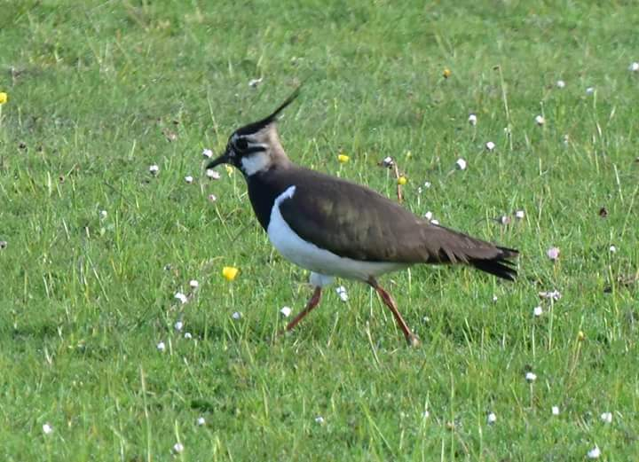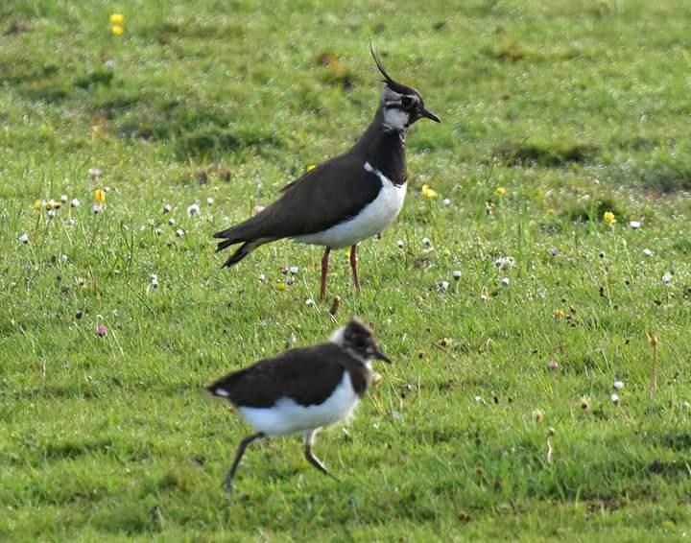
Nesting Lapwings on Hollin Busk 2017
These studies show that a diverse range of species are present in the fields and wooded parts of this area.
A funded project is currently underway by Steel Valley Project to support a local population of willow tits in Fox Glen and this involves encouragement of the right habitat and also the careful control of water drainage through the Glen. Any changes to water flow into Fox Glen could have a significant impact on this project.
There is currently a green finger of land that runs from Manchester Road up towards Bolsterstone that separates Deepcar from Stocksbridge. Fox Glen is part of this green continuity. The proposed housing development will close off the top of Fox Glen so that it is totally isolated and it will sever this green finger of land.
In 2017 Sheffield City Council asked the developers to complete an EIA primarily in relation to the local bird population. The developers appealed for a screening direction from The Secretary of State, who, based on the advice from Natural England, ruled that an EIA was not required. FOHB believe that the original scope ie just birds, was too narrow and that the whole of the environmental aspects should have been considered.

8. Water Management and Drainage
The proposed development site is immediately adjacent and downhill from an old ganister mine, to the south of the site across Hollin Busk Lane. The site is also adjacent to the old Hollin Busk Colliery, which was to the west of the site. There are undoubtedly shallow coalmine workings under this area and also ganister workings that may be deeper. No detailed study has been made of these workings. These probably influence underground drainage or may have more significant implications such as sinkholes.
Natural drainage on the fields of Hollin Busk is down into Clough Dike and after heavy rain surface water is regularly seen running across the fields to the north of Hollin Busk Lane.
There is also significant water runoff from higher areas around the Golf Course such that there is regularly water running down Carr Road during periods of heavy rain.
It is a regular occurrence for drain covers to overflow down Carr Road in periods of high rain and sometimes sewage spills out onto the road.
Local residents living at Bennewell and The Boskins, older properties adjoining Royd Farm, were subjected to a major flood around 2010 when a torrent running down Carr Road entered the properties flooding out the ground floors.
Foul water from the development is proposed to be directed into the 225mm combined sewer on Carr Road. There is concern that there is not the capacity to take this increased load. Local residents have very recent experience, earlier in 2017, of 2 instances of sewage overflow on The Royd and one at the Carr Road/The Royd junction (overflow into the property know as The Boskins).
The developers have proposed that surface water drainage should be directed into Clough Dike. Fox Glen is already an area that is subject to water surges where there is currently water management activity by Steel Valley Project as part of the willow tit project. The proposal for a more directed water flow down Clough Dike, as opposed to just ground seepage, is not a sensible option.

9. Heritage
The area has traditionally been a farming landscape with discrete farms dotted along the hillside. At Hollin Busk, Royd Farm was the main farmstead, of which part is believed to date to the 16th century with 18th century extensions.
The proposed housing development would engulf the grade 2 listed buildings of Royd Farm. New housing would encircle, on the south, west and north sides, this historic building and will have a major impact on its significance and setting.
The heritage document submitted by the developers is a desk- bound exercise and is inaccurate and misleading. There are now 4 separate residencies making up what was the old Royd Farm and outbuildings. These are now Royd Farm, Bennewell, The Boskins and Glen View. There are no “modern farm buildings obscuring the view”.
There are currently exceptional views from Royd Farm to the west across grass fields and some of the sunsets are stunning. New housing, and the proposal to include “buffering” by a 1.8m fence, hedging and trees, would totally obscure this view. Similarly, several of the existing houses facing west on Carr Road appreciate the same view across open green fields.
Submitted plans show that the proposed housing would come up to the back gate and within 5m of the listed stone pigsties at Royd Farm.
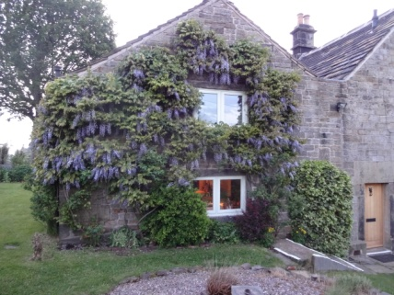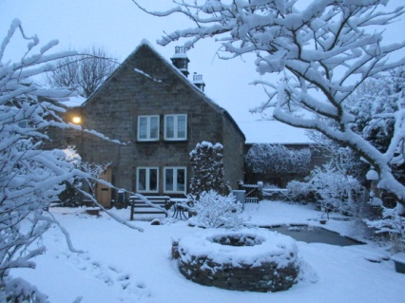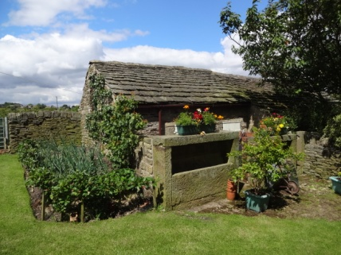
Views of Royd Farm and listed pigsties
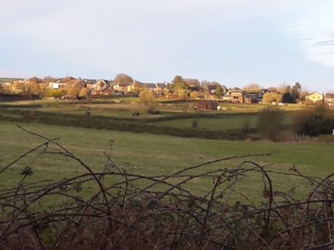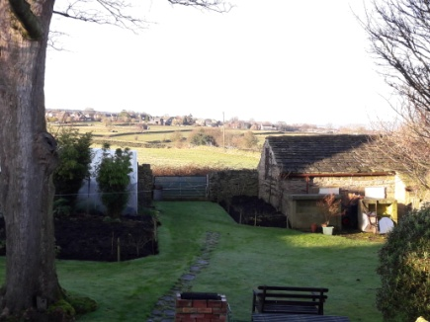
Views of the Hollin Busk fields from the back of Royd Farm
10. Conclusions
Friends of Hollin Busk believe that all of us have a responsibility to strive to safeguard a sustainable future and an enjoyable environment for our children and grandchildren. This should be a legacy to benefit all and not just a few. Ensuring better lives for ourselves should not mean worse lives for future generations.
The protection of open green spaces for all to enjoy is an essential requirement , as is the provision of new, good, affordable housing.
Sheffield City Council have a clear policy for Hollin Busk outlined in the Sheffield Core Strategy 2009. The protection of this “Open Space” should be maintained and built into the new Sheffield Plan.
Sheffield City Council should not allow opportunistic developments on inappropriate greenfield locations, particularly when there are large, new housing developments on brownfield land nearby with better access to main routes. Friends of Hollin Busk want to strengthen Sheffield City Council’s resolve. The Hollin Busk fields should be given greenbelt status as was originally intended.
There is an extremely high level of local feeling to retain these green open fields. A very high number of objections have been registered on the Sheffield City Council website (300 to date 6/1/18).
The Government’s Housing White Paper published February 2017 stated “the right homes in the right places” and made a commitment to “the protection of open countryside”.
The Secretary of State refused permission to build on this green space in the past. This should be maintained.

Friends of Hollin Busk, January 2018.
(author Peter Morgan)

Friends of Hollin Busk are:- Peter Morgan, Howard Mills, Elaine Smith, Dave Hansell, George Glover and Chris Spenceley.

